2. Fit a default random forest

(a) **Report variable importance and comment: which variables seem most**

**important and which seem least important?**

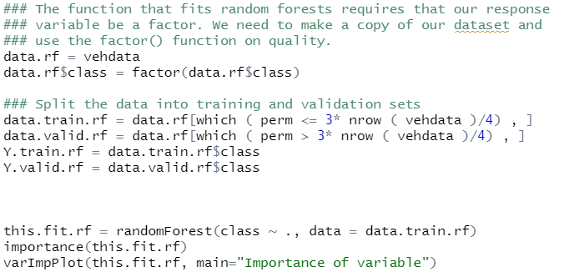

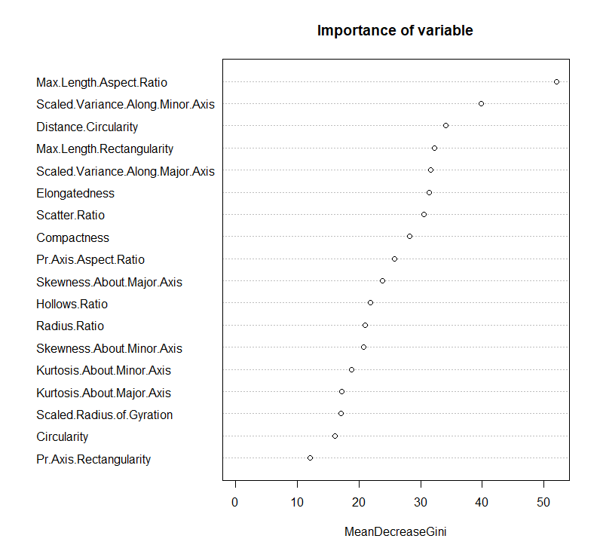

Max.Length.Aspect.Ratio looks most important and Pr.Axis.Rectangularity seems less important.

(b) **Report test error and compare it to other methods**





It shows quite lower error compare to classification tree and Naïve Bayes.